November monthly report
Project Title:
Conversion of post-combustion gas from cement manufacturing to syngas by electrochemical CO₂ capture and reduction
……..........................................................
Dr. Pongkarn Chakthranont
Sothearoth Heng
NCR ID: 803198
Under the supervision of
Dr. Pongkarn Chakthranont
Contract Number: NCR-NN-2024-22237-EN
November 2024

- Tasks list for November
- Long-term CO₂ electrolysis under 0.1-1.0M KOH anolyte with Ni foam and IrO₂/TiPt anodes at 100mA/cm²
- CO2RR of Ni0.5SAC with 5%XC-2 ionomer
- CO2RR of PANI@Ni0.5SAC with higher Ni0.5SAC mass loading
- Experimental Procedure
Preparation of Ni0.5SAC@PANI and cathode electrode
Briefly, Ni0.5SAC (150mg) and PANI (75mg) were mixed in 15ml of IPA to make a dispersion solution. Subsequently, the dispersion solution was sonicated for 2h, followed by overnight stirring at a room temperature. Afterwards, the dispersed Ni0.5SAC@PANI was filtered out, followed by several washing with DI. The solid residue was then overnight dried at 80°C to finally obtain Ni0.5SAC@PANI powder. 225mg of Ni0.5SAC@PANI was added into a 10ml of IPA, followed by adding 381µL of XC-2 binder and sonicating for another hour to make an ink solution. The ink solution was then sprayed onto Sigracet 39BB carbon paper to obtain a mass loading of approx. 0.18 ± 0.1 mg/cm².

Long-term stability of CO₂ electrolysis
A 5 cm² MEA electrolyzer was used to evaluate the CO2RR performance under modulated operating conditions. The Ni foam, bipolar membrane (BPM), and different cathode catalysts were employed as the anode, membrane, and cathode electrode, respectively. 1000 ml of 0.1-1M KOH was recirculated and used throughout the experiment as the anolyte at 8 ml/min. The KOH electrolyte was refreshed every 24h, while the NiSAC cathode was also flushed with 10ml of DI water.The humidified CO₂ gas stream was introduced into the cathodic inlet under total flow rates of 150 ml/min. Meanwhile, the cathodic outlet was directly injected into an online gas-chromatography for gas products analysis.

- Results
Comparing CO2RR performance of NiSAC+PTFE and MWCNT with other additives under diluted 15%CO₂
Further studies on modifying the Ni0.5SAC catalyst were conducted by introducing Ultraflon PTFE and MWCNT to enhance its hydrophobicity. A comparison of Ni0.5SAC with various modified versions is shown in Fig. 1. Pyr-Ni+PTFE and blend-Ni+PTFE exhibited similar performance to Ni0.5SAC, while blend-Ni+MWCNT demonstrated high HER activity, likely due to Ni active site blockage from MWCNT. In contrast, blend-Ni+PANI and blend-Ni+P showed excellent CO selectivity and stability, with FE(CO) >77% over a 3-hour operational period. Furthermore, A blend-Ni+PANI with higher m/l of 3.2mg/cm² resulted in a significant decrease in CO selectivity.
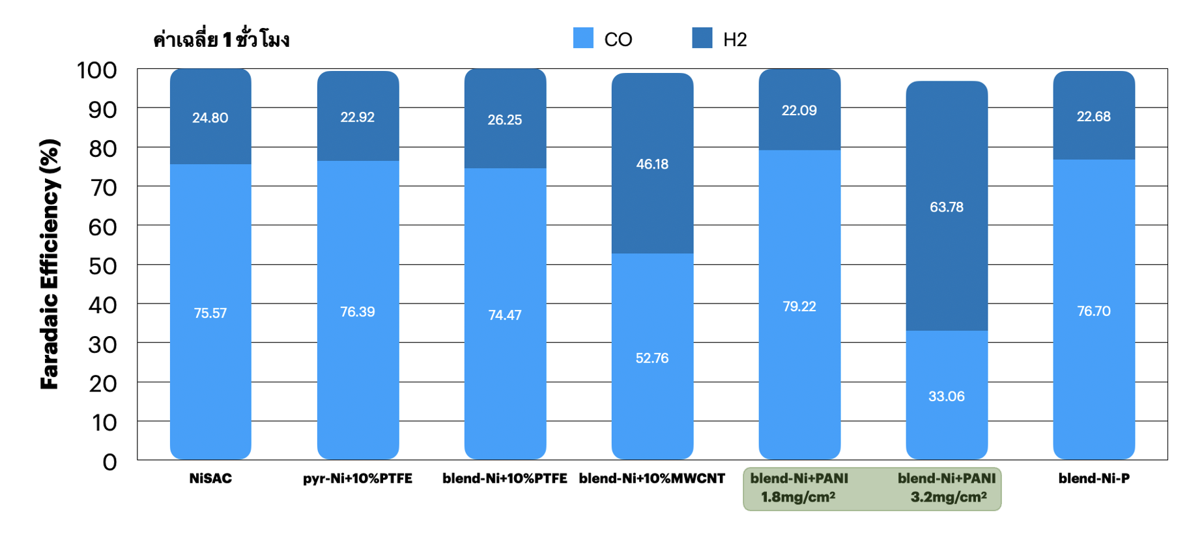
Figure 1. Faradaic efficiency of modified Ni0.5SAC with other additives under a diluted CO₂ condition at 200mA/cm²

Influence of Sustainion XC-2 ionomer loading on CO2RR performance of NiSAC under 15%CO₂ at 200mA/cm²
In the BPM system, designing the thickness of the anion exchange ionomer in the catalyst layer is crucial for improving local carbonate availability, CO₂ regeneration, and limiting K+ concentration at the catalyst/membrane interface. This ionomer has a positively charged backbone, which can significantly impact local ionic transport. As shown in Fig. 2, a Ni0.5SAC catalyst with 10% XC-2 loading achieved 76% FE(CO). However, increasing XC-2 ionomer loading to 20% and 30% may block Ni active sites, reducing CO₂ accessibility and CO selectivity. Meanwhile, lowering XC-2 ionomer loading to 5% showed the lowest FE(CO) of 51% which could be attributed to inconsistent dispersion of NiSAC onto carbon substrate.
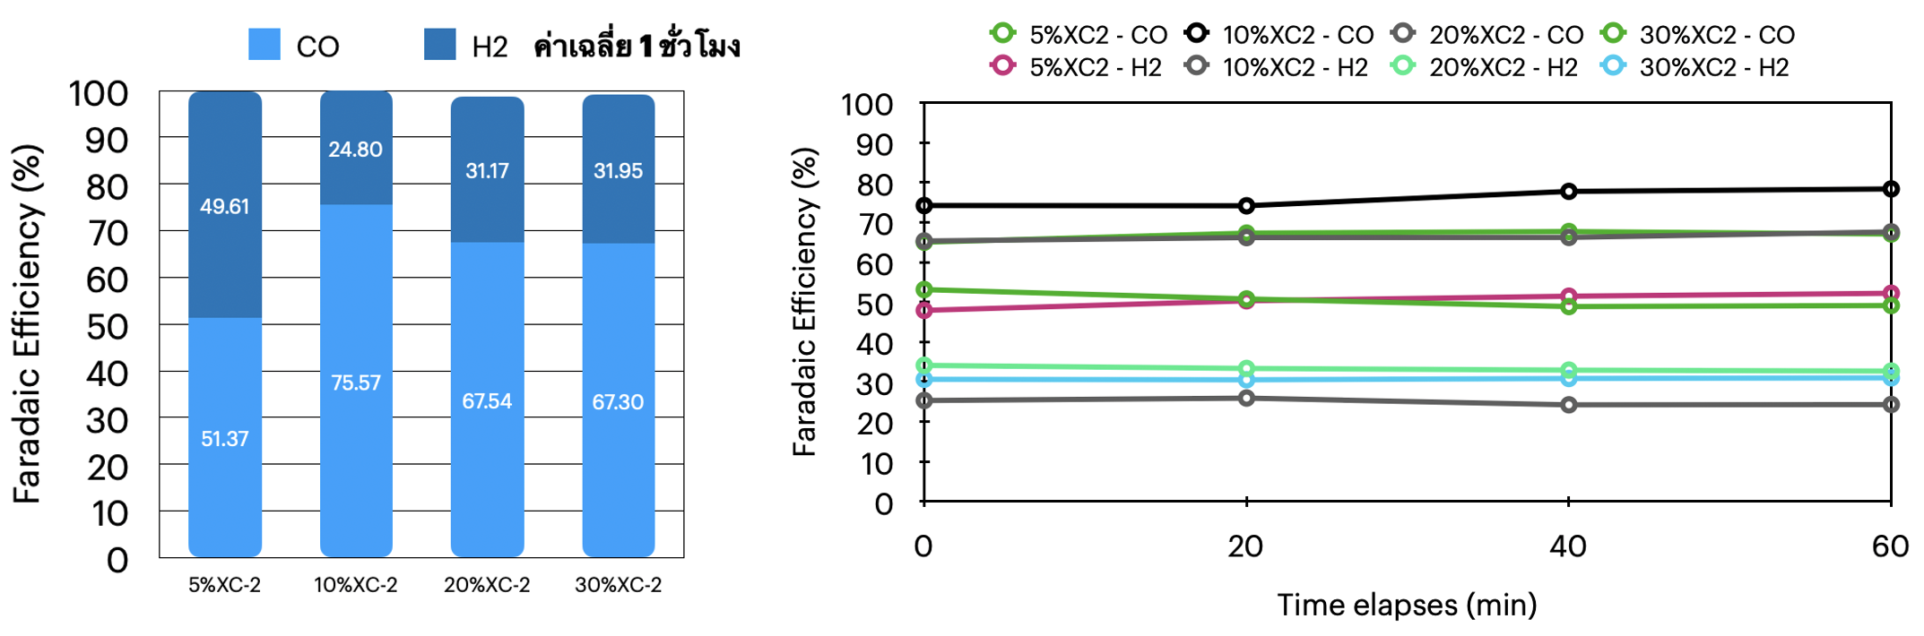
Figure 2. Faradaic efficiency of a Ni0.5SAC cathode with 5-30%wt XC-2 ionomer loadings under a diluted CO₂ condition at 200mA/cm²
Long-term CO₂ electrolysis of Ni-SAC under a pure CO₂ condition with Ni foam and 0.1M-1.0M KOH anolyte at 100mA/cm²
To further mitigate K+ crossover, which could result in salt formation in the cathode region, the influence of KOH anolyte concentration on BPM system stability was tested under pure CO₂ with 0.5M and 1M KOH at 100 mA/cm². As shown in Fig. 3, a 1M KOH system exhibited a slightly lower cell voltage (3.32V) than the 0.5M system (3.49V). However, significant salt buildup occurred in the 1M KOH system after 13 hours, requiring frequent regeneration. After regeneration with DI water, the GDE became wetted, reducing hydrophobicity and causing HER activity over CO2RR. In contrast, the 0.5M KOH system maintained stability with FE(CO) >90% for over 40 hours, likely due to the lower K+ concentration, which reduced crossover and prevented severe salt formation. Salt formation began after 15 hours and required regeneration after 30 hours, as CO₂ output decreased significantly (from 150 to 70 ml/min over time). Frequent DI water regeneration can reduce GDE hydrophobicity, so alternative methods, such as pulse electrochemical regeneration or using a more diluted KOH concentration, may prolong cell lifespan. To further improve the stability of the system, 0.25M and 0.1M KOH electrolyte were utilized to mitigate K+ crossover and salt precipitation on the NiSAC cathode. The CO₂ electrolysis system with 0.25M KOH demonstrated a similar trend to 0.5M KOH system, while further diluting the KOH to 0.1M caused a significant drop after 18h, even refreshing the electrolyte.
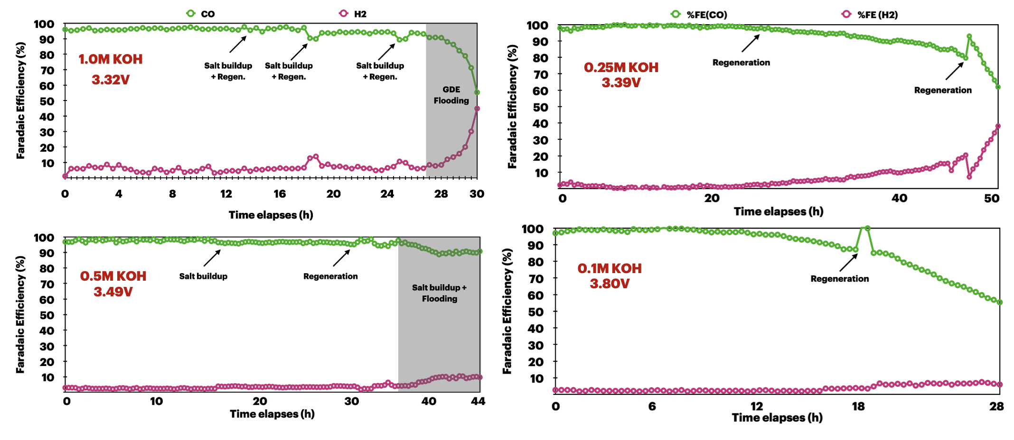
Figure 3. Long-term stability of Ni0.5SAC under a pure CO₂ with 0.5M and 1M KOH anolyte and Ni foam anode at 200mA/cm²

Long-term CO₂ electrolysis of NiSAC under a pure CO₂ condition with IrO₂/TiPt and 0.25M KOH anolyte at 100mA/cm²
To further confirm the instability of the previous electrolyzer system under a diluted 0.25M KOH electrolyte with a cell configuration of NiSAC/BPM/Ni foam, the IrO2/TiPt mesh was replaced as an anode electrode. As can be seen in Fig. 3, the stability of the overall system was moderately prolonged over 65h with a full cell-voltage of 3.79V. These results indicated the importance of the selection of anode material under a diluted KOH electrolyte.
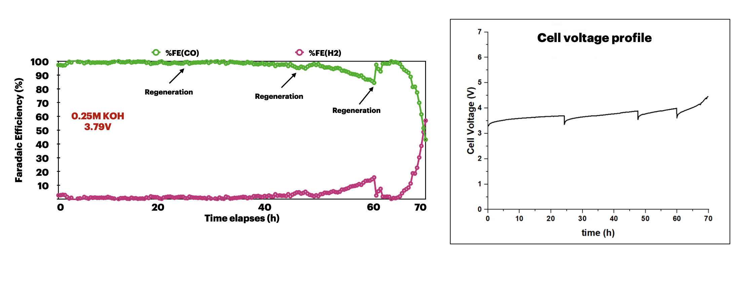
Figure 3. Long-term stability of Ni0.5SAC under a pure CO₂ with 0.25M KOH and IrO₂/TiPt anode at 200mA/cm²

- Upcoming tasks
- Long-term stability under a pure CO₂ with diluted KOH electrolyte at 200mA/cm²
- Long-term stability under flue gas conditions

